

CS516 - Computer Vision

Prof. Russell Butler

Students

Bhoopalsinh Musale 002269332

Sara Eskandarirad 002279327

**Part 1: Python viewer (50%)**

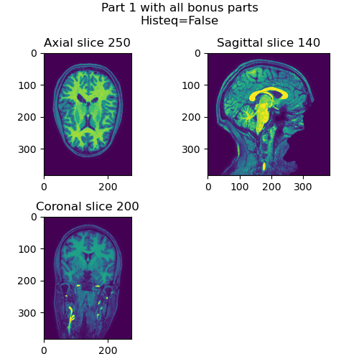

**part_1(brain=brain, slice_arg=250, view='all', histeq=False)**

* **Implemented all bonus part**
* **Scrolling and key events are implemented.**

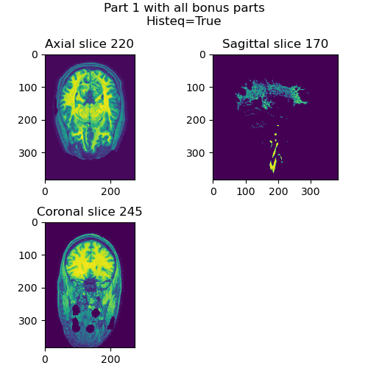

**part_1(brain=brain, slice_arg=250, view='all', histeq=True)**

* **Output when histeq=True**
* **Here our own implementation of histogram equalization does not perform well.**

**Part 2a (10%):**

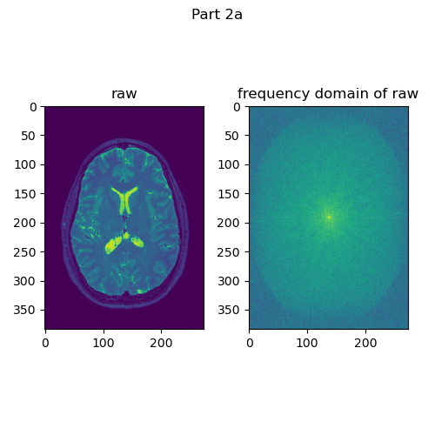

**Part 2b (20%):**

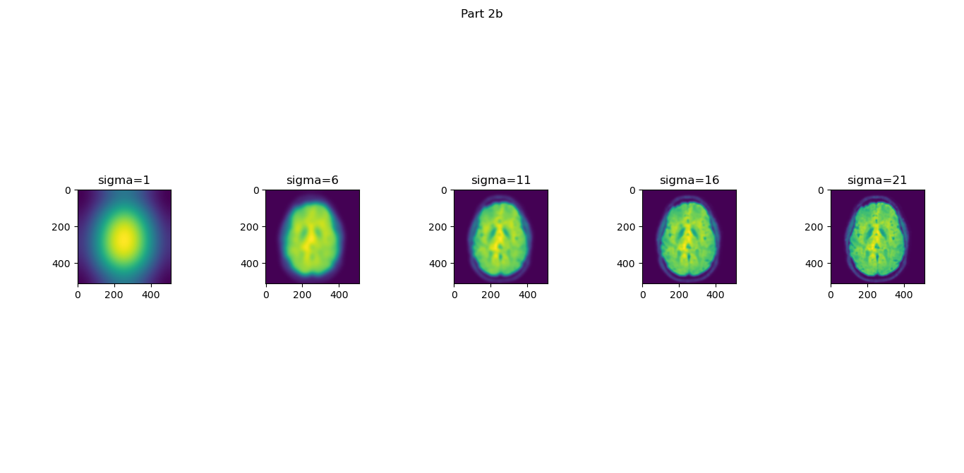

**Part 2c (20%):**

* **With all modalities**

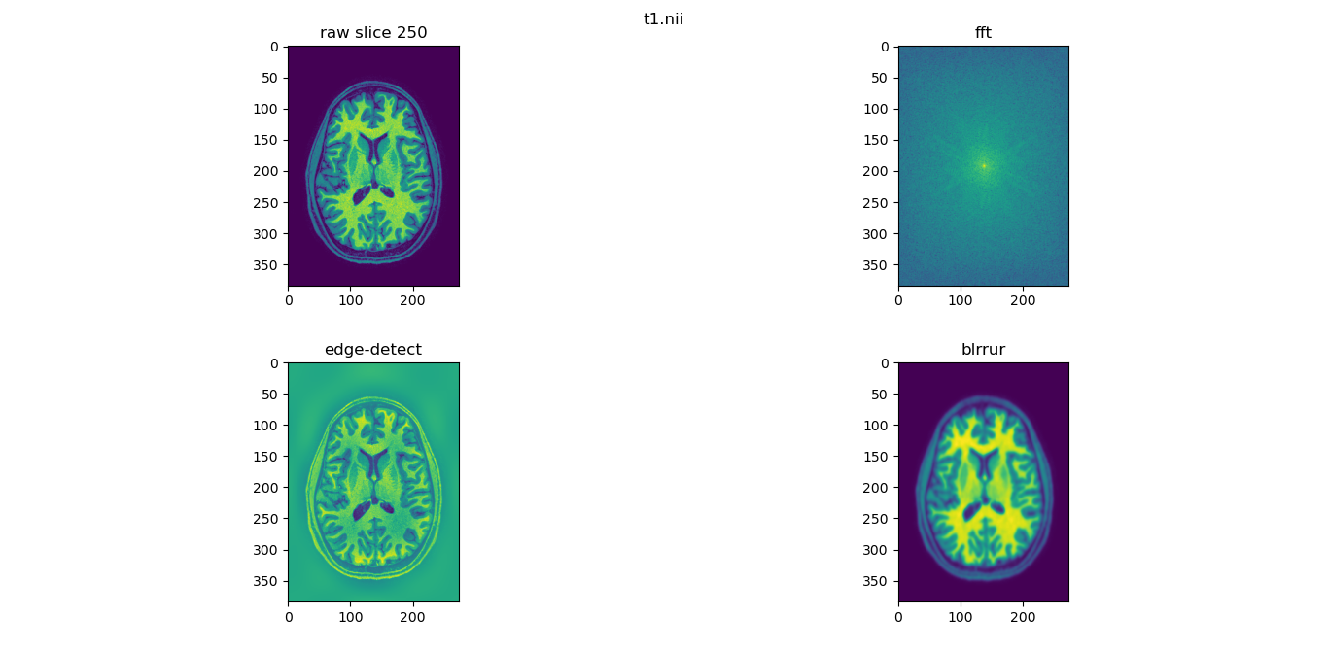

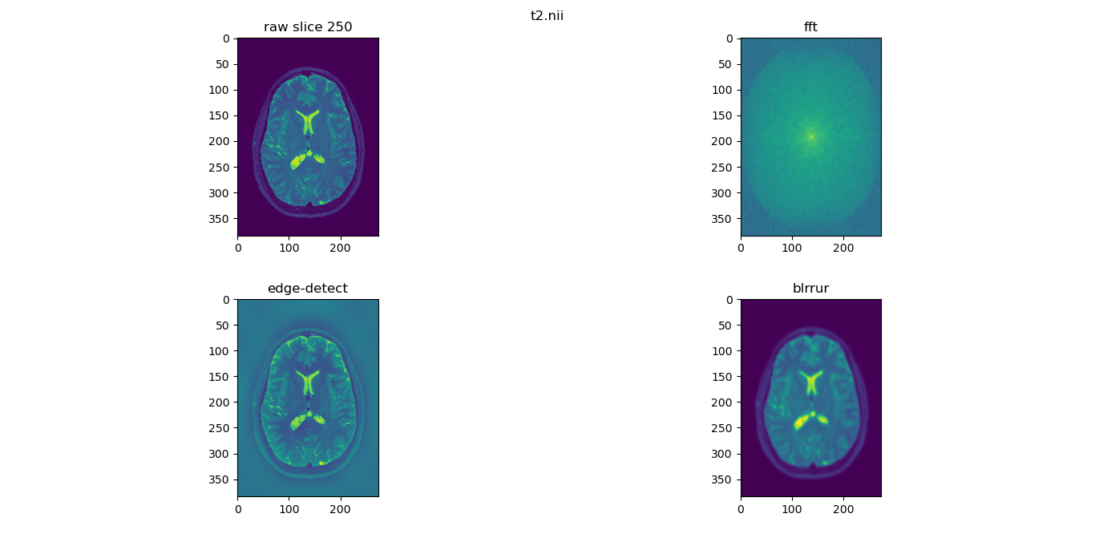

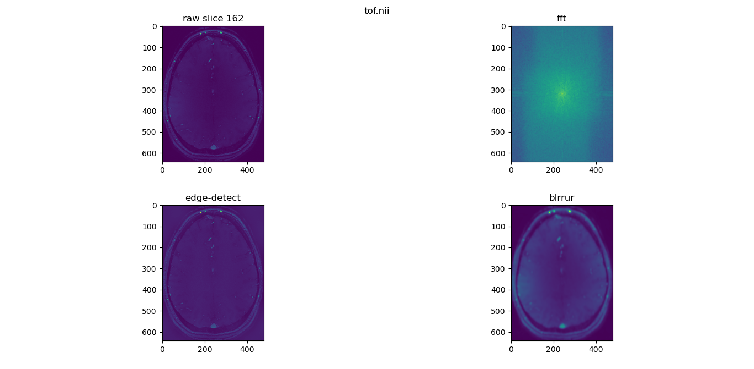

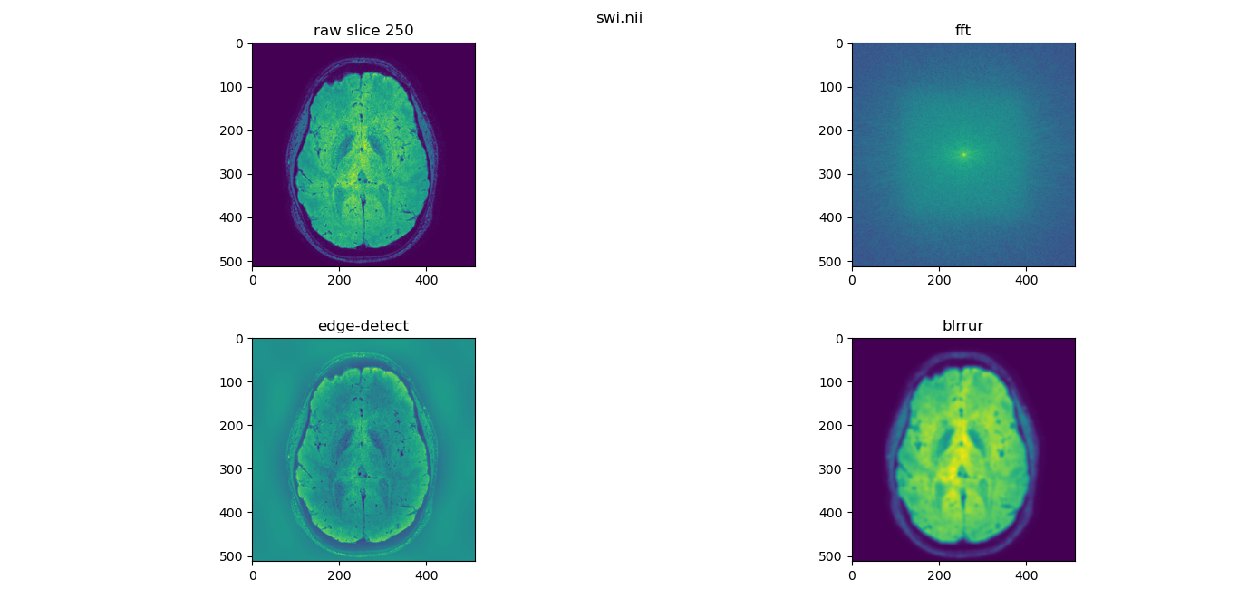

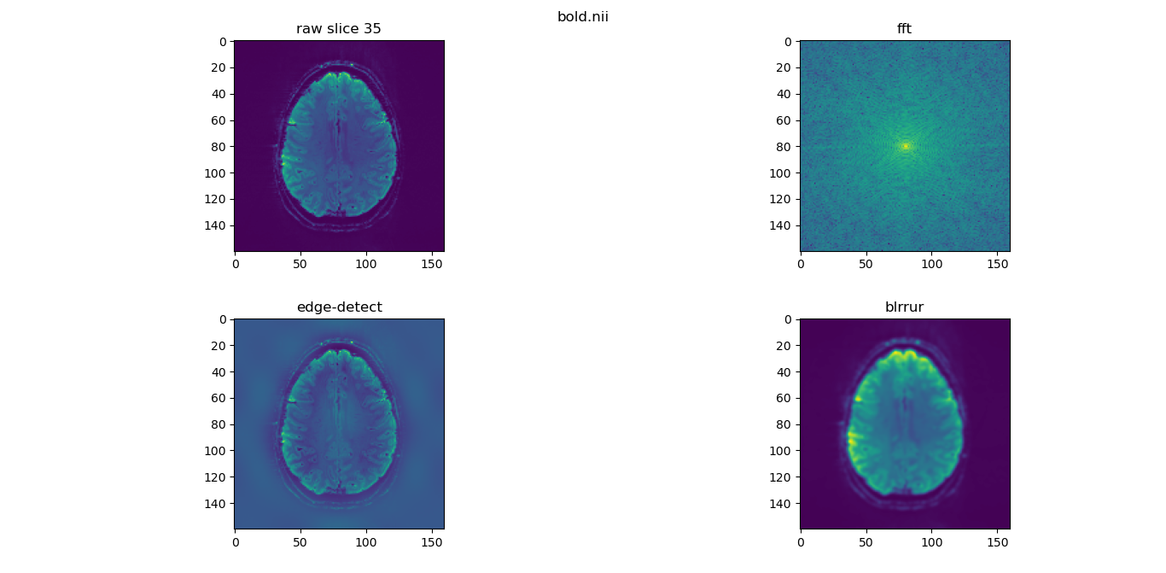

* Bonus question +2.5%: Experiment with different filter shapes. What happens if you use a bar or a square, instead of a gaussian smooth? **– incomplete**
* Bonus question: +2.5%: all the images so far have skulls. Here is an image with no skull. Can you explain how this image was created? Give details on how the skull was removed from the image.

**An**s=> Component-based extraction may have been used here for extracting the brain. Meaning, all connected pixels are selected first which will form two groups; one group will contain all the pixels of the actual brain and another group contains pixels of the skull. Once this group is done then pixel group with a larger value of pixels than a certain threshold is selected which is nothing but the actual brain.

* **Bonus question:** +10% how did I create Mystery image (below)? Explain what the contrast is based on.

**An**s=> It is produced using gaussian blur filter on “bold.nii” modality, with very high sigma value around 150. Which is then plot with “gray” colormap.